Lab 1 First OpenGL Application

1. Using the code provided on Blackboard, create the simple white triangle application discussed in the lecture.
2. Change the colour of the triangle so the whole triangle is green.
3. Change the colour of the triangle so it is a mix of three colours as shown in the lecture.

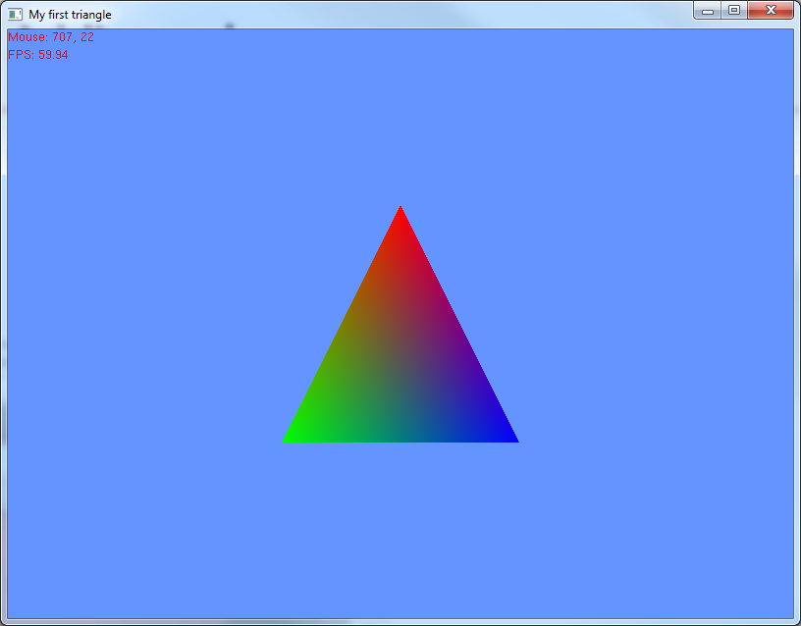

1. Update the triangle drawing code to create a square. This requires drawing two triangles that will form a quad.  
   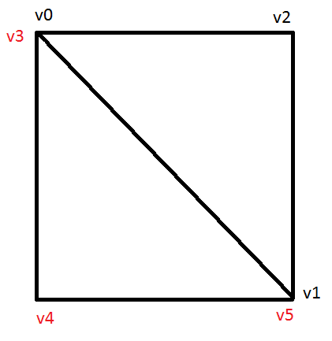
2. Investigate other drawing methods, draw your own shapes using the follow drawing primitives (you may want to enable wireframe mode to see the shape):
   1. Triangle strip: Draws a connected group of triangles. The first three vertices define the first triangle, the 4th vertex along with the 3rd and 2nd vertex define the next triangle, and so on.  
      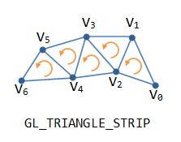
   2. Triangle fan: Draws a connected group of triangles. The first three vertices define a triangle. The 1st, 2nd and 4th vertices are used to describe the next triangle and so on.  
      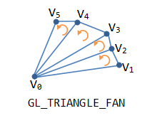
   3. Quads: Treats each group of four vertices as an independent quadrilateral. Take care to make sure the vertices are specified in order and anti-clockwise.  
      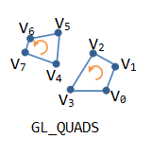
   4. Polygon: Draws a single, convex polygon.  
      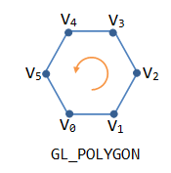
3. Add user interaction so when the ‘r’ key is pressed activate/deactivate wireframe rendering.